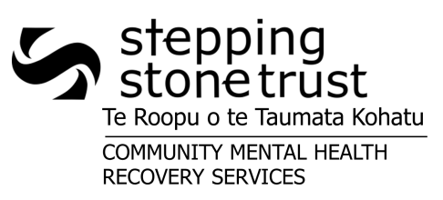
REFERRAL TO STEPPING STONE YOUTH SERVICES
Residential
Respite
Mobile
Community Mental Health Work
This form can be used to refer a young person to any of Stepping Stone Youth Services. Please select any of the options you are interested in referring to:
Patient Label

If you wish to discuss which services might be appropriate for the young person you are referring, please phone Malcolm (03-338-6390 ext 735). For respite referrals, please make contact directly with the Respite/Residential service to discuss a booking (03 332 6417/337 4997 or 027 489 5374).
Attach HEALTHLINKS FACE SHEET with CURRENT information including:
CLIENT DETAILS / NEXT OF KIN DETAILS / GP / Case Manager and Consultant
Attach CONTACT AND DISCLOSURE form with Stepping Stone Trust added.

Attach CRISIS/ACTION/TRANSITION PLAN including current risks. Clearly state objectives and role for SST.
Attach current/most recent PSYCHIATRIC SUMMARY.
Attach MEDICATION SCRIPTS & QUALMED CHARTS for Respite & Residential NB Blister packs required
Additional CLIENT INFORMATION required:
- Legal Status: (eg. Mental Health Act, CYFS Act, Bail Conditions etc.)

- Client’s Diagnosis:

- Physical Health Issues (including Allergies):

- Alcohol and Drug Usage/History:

- Client’s Current Daily Activities:

- Are there any gender issues with staff that we should be aware of?

- What insights does this young person have about their mental health?

- Objectives of Referral to Stepping Stone Services:
RESPITE ONLY (Please contact Youth Respite to enquire about availability, (03 3326417 or 027 489 5374):
Clients with a history of arson and/or sexual or physical aggression towards others are unlikely to be accepted.
A “Plan B” is essential (i.e. an alternative accommodation option).
Are there any conditions on this young person coming and going from the house?

If there is an incident that requires the young person to be discharged from Respite, what is the plan for where they will go?

If this client goes AWOL, who should our first point of contact be?

MOBILE and COMMUNITY SUPPORT WORK ONLY:
Are there any issues around staff going to this client’s home address?

Are there any specific dangers for the client at their current address?

RESIDENTIAL ONLY:
Please be aware accessing Youth Residential will require the following process:
1. An initial meeting involving case manager, client + family, Youth Residential team.

2. Development of a Support Plan from the initial meeting.

3. Offer of residential placement dependent upon agreement of Support Plan.
This referral will be actioned once we receive all the required information.
Referrer Name: _______________________________________
& Signature: _________________________________________ Date: _______________
This form can submitted to SPOE Co-ordinator via:
- Email: youthreferrals@stepstone.org.nz (Best pathway for prioritisation of referral)
- Post: PO BOX 33-103, Barrington, Christchurch
- Fax: (03) 338-6398
- For Respite referrals, please send the referral to Youth Respite/Residential service and to the SPOE Co-ordinator. Respite Email: yresidential@stepstone.org.nz Respite Fax: 338 7262
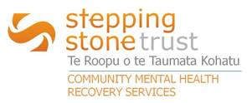
CRITERIA FOR ACCESS TO YOUTH SERVICES
SERVICE | CRITERIA FOR ACCESS | ADDITIONAL NOTES
Youth Residential | - Is aged between 14-18  - Is currently and will remain under SMHS (Specialist Mental Health Services)  - Clients 18 and over can be offered a place within Youth Residential if:  - The referral has been received through the ROG (Residential Options Group) pathway, and  - If there are no younger people under 18 on the waiting list for the service | - A client’s access to Youth Residential ends at the time of discharge from SMHS services
Youth Respite | - Is aged between 14-18  - Is currently under SMHS  - Has a ‘Plan B’ for accommodation, if discharge is required | - Clients over 17 are able to access Adult Respite  - Medication Prescribed Chart and Scripts are mandatory  - Respite slots are Mon/Tue, Wed/Thu, and Fri/Sat/Sun
Youth Mobile | - Is aged between 14-24  - Is currently and will remain under SMHS  - Requires support at a high level – with the frequency of visits a maximum of daily, and a minimum of twice weekly
Youth CMHW | - Is aged between 14-24  - Has been under SMHS in the last 12 months | - A client can access the Youth CMHW service for up to 12 months following their discharge from SMHS  - As SST (Stepping Stone Trust) has a contract for 1.5FTE Rural CSW, referrals for rural clients need to be at the top of the waiting list and picked up as soon as the next worker is available

